SOLID COLOR DISCLAIMER
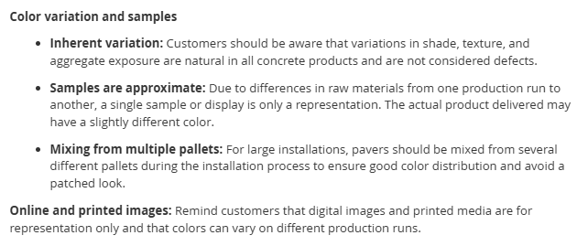
Production of Solid Color Pavers vary from batch to batch inside of paver lots.
Natural Grey and Natural White have no pigment and can vary not only in intensity but also in hue.

I understand that solid color pavers are controlled by raw materials and may have hues. This is not a warrantable item.

Sign:_______________________________________ Date: _________________

Thank you
Tremron
A Quikrete Company

